
Home learning for Year 4
Week Beginning Monday 23rd March 2020
Spelling/Phonics:

Words ending with cian, sion, tion and ssion.
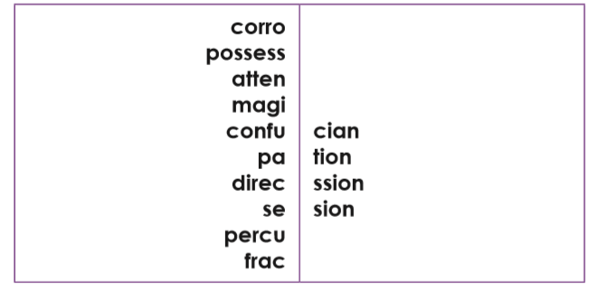
Identify which ‘shun’ ending is needed and then practice the words using one of the spelling strategies in your homework folder.
E.g corrosion

Spelling rules for Parents, if you want to discuss:
Strictly speaking, the suffixes are ‘-ion’ and ‘-cian’.
• ‘-tion’: the most common ending; used if the root word ends in ‘t’ or ‘te’
• ‘-cian’: common in occupations; used if the root word ends in ‘c’ or ‘cs’
• ‘-sion’: used if the root word ends in ‘d’/’de’ or ‘s’/’se’ *
• ‘-ssion’: used if the root word ends in ‘ss’ or ‘mit’
*Exceptions: attend/attention, intend/intention

Reading:


- Why do you think the boy is looking through a hole in the fence?
- What do you think he might see?
- How might he feel about what he has seen? Why?
- Think back to our work on the book ‘Journey’, and use your imagination. What would you like to be the other side?
- Do you think the boy will go over the fence?
- What do you think he will do next? What would you do next?

Please continue to read with your child every night.
English:
https://www.youtube.com/watch?v=tPdqnY9NJEM&safe=true
Here is a video of Anne Fine, explaining her top tips for writing new stories. We have been exploring her work through looking at ‘The Diary of a Killer Cat’ and writing our own diaries. Please create a poster about how you can use your favourite top 3 tips when creating your own stories.

Maths:
https://www.teachactive.org/my-account/?code=XQT6N
Select Year 4 and then the teaching objective money. Please complete the lesson Missing Cash!

PE/Active lesson:

Joe Wicks active workout
https://www.youtube.com/user/thebodycoach1/videos?safe=true

At 9am every day, Joe Wicks is leading an exercise class for an hour. Please log on when you can, at least once this week. The activities will be recorded on his youtube channel so they can be accessed at any time.

Topic: Teeth
https://www.bbc.co.uk/bitesize/topics/z27kng8/articles/zsp76yc
Use this link to learn about the different types of teeth and their jobs. Once you have done this, choose one type of tooth and create an information page about it. (see template below)

10 top tips for staying safe on the internet
1) Don’t post any personal information online – like your full name, email address, mobile number, etc.
2) Think carefully before posting pictures or videos of yourself. Once you’ve put a picture of yourself online, most people can see it and may be able to download it, it’s not just yours anymore.
3) Keep your privacy settings as high as possible!
4) Never give out your passwords.
5) Don’t befriend people you don’t know.
6) Don’t meet up with people you’ve met online. Speak to your parent or carer about people suggesting you do.
7) Remember that not everyone online is who they say they are.
8) Think carefully about what you say before you post something online.
9) Respect other people’s views, even if you don’t agree with someone else’s views doesn’t mean you need to be rude.
10) If you see something online that makes you feel uncomfortable, unsafe or worried: leave the website, turn off your computer if you want to and tell a trusted adult immediately.

