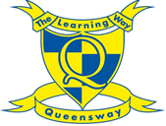
Home learning for Year 4
Week Beginning Monday 20th April
Spelling:
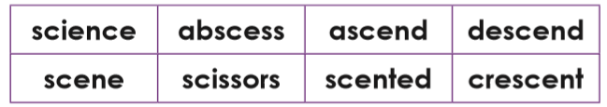

Look at the words in the list above, what do you notice about them? Which part of the word do you think makes them tricky to remember?

Can you write sentences using your spellings? How many can you get into one sentence? Then have a go at creating a spelling swirl.
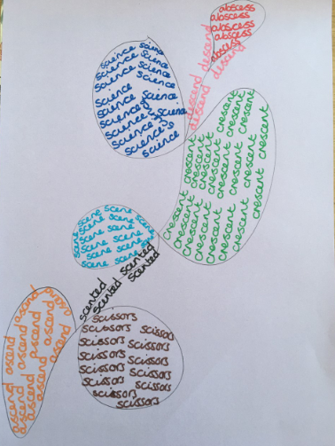

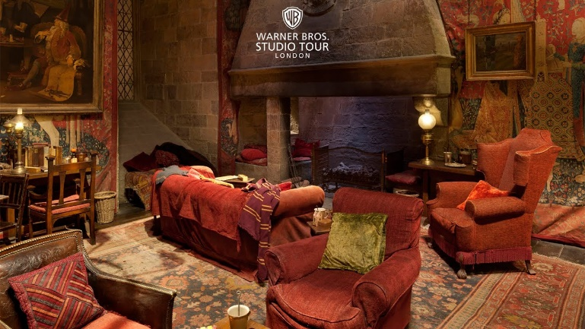
Grammar: expressing time and cause by using prepositions.

Look at the following picture and describe where different objects are in the room using prepositions. Share your sentences with your partner, did you write about different things?
Now repeat the same activity but this time use these place prepositions: beside, beneath, under, in, on, through and behind.
Prepositions can also be used to tell us about time, and can be used to tell the reader about how something has been caused by something else. For example: Due to it being night time, the lamp was switched on. During the day, Ron left his scarf under the cushion.

Reading:
Listen to the story of ‘The Egyptian Cinderella’ by clicking this link: https://m.youtube.com/watch?v=dSVfIc4l8Lk
Listen to the story a few times and then answer the questions below.

- Look at these words and phrases from the text: taunted, gilded, holding court, chores, awe, tunic, decree, pronounced. Match the definition to the words to develop your understanding of the text.

- To have teased somebody in an unkind way.
- To have said or announced something.
- A sleeveless piece of clothing that can be different lengths.
- An official order.
- A feeling of wonder or amazement.
- A gathering of people where the organiser is the centre of attention.
- Tasks that need to be done regularly at home such as washing, cleaning, ironing.
- Covered in a thin layer of gold or gold paint.

- How did Rhodopis feel at the beginning of the story? Did this change as the story progressed? Use the text to help you give examples.
- At the start of the story, who took Rhodopis and from where?
- Why did the other servant girls dislike her more after her master gave her the gift?
- Give one example of how the Pharaoh described Rhodopis.
- Do you think Rhodopis will be a kind and caring queen? Explain your answer using evidence from the text.
- Is this story similar to any others that you have read? How? What are the differences between the stories?

English:
We have read ‘Diary of a Killer Cat’ and watched the video clip by Anne Fine. This week we are going to be writing imaginary letters to her, asking about the books she has written.
If you would prefer to write to a different author, whose books you have enjoyed, this is fine.

Task one:

Create a plan for your letter. What do you want to tell Anne Fine? Use the bullet points below to help you create a thought shower of ideas.
You may also include some of the language you will include in your letter – examples: In my view, in addition, furthermore, I am writing this letter to…

- Paragraph one: Which books have you read by Anne Fine? What did you like about each book? Which one was your favourite? Why?
- Paragraph two: Give some examples of characters or parts of the story that you liked – use examples from the text. You might give examples here of the language that she uses to grab the reader’s attention. For example: I love how sarcastic Tuffy is and how he pretends that he doesn’t care about being in trouble all of the time. I love the use of rhetorical questions that he uses such as so what?
- Paragraph three: Ask questions about a character or setting of your choice that the author has created. You could also ask some questions about the author here.
For example: I love the mischievous character of Tuffy. Is he based on a real cat that you have owned or is he made up?
- Paragraph four: Thank the author for their writing, describing the impact that it has had on you as a reader. Explain that you would love a response to your letter.

Task two:

Write your letter, thinking carefully about structuring your paragraphs. Remember to add detail and some examples from the texts that you have read. When writing your letter, remember the tone needs to be formal. We are writing to somebody that we do not know and therefore need to think carefully about the language choices we make.

Would you start your letter with ‘Hello’ or ‘Dear’? How might you end a formal letter?

Maths:
Task one: Can you find 1000 more or less than a given number?
Choose the amount of time you would like to challenge yourself with. How many questions can you answer in 1 minute?

http://www.snappymaths.com/addsub/addsubp10/interactive/addsub1000int/addsub1000int.htm

Task two: Spend 15 minutes a day on Times Table Rock stars. Challenge your friends and teachers! We have set another tournament this week between both of our classes – let’s see who wins this round!

PE/Active lesson
Please keep joining in with Joe Wicks every morning at 9.00.

https://www.youtube.com/user/thebodycoach1/videos?safe=true

Also it would be good to keep practicing your times tables using the Supermovers. Please choose the times tables you are finding the most difficult and practice these.

https://www.bbc.co.uk/teach/supermovers/ks2-maths-collection/z7frpg8

Topic: History

Our History topic this term should be all about Ancient Egypt. Before you start researching, write down what you already think you know about them and what you might like to find out.
Then go onto BBC Bitesize and read the information.

https://www.bbc.co.uk/bitesize/topics/zg87xnb

Create your own poster showing what you have learnt about them. Try to add pictures and captions. What is the most fascinating fact? What else might you like to find out?

Also you could start to collect junk such as cereal boxes, milk cartons etc. to make your own Egyptian artefacts later on. Last year children made pyramids, sphinx and a Tutankhamun Sarcophagus. Have a think what you might like to make!

10 top tips for staying safe on the internet
1) Don’t post any personal information online – like your full name, email address, mobile number, etc.
2) Think carefully before posting pictures or videos of yourself. Once you’ve put a picture of yourself online, most people can see it and may be able to download it, it’s not just yours anymore.
3) Keep your privacy settings as high as possible!
4) Never give out your passwords.
5) Don’t befriend people you don’t know.
6) Don’t meet up with people you’ve met online. Speak to your parent or carer about people suggesting you do.
7) Remember that not everyone online is who they say they are.
8) Think carefully about what you say before you post something online.
9) Respect other people’s views, even if you don’t agree with someone else’s views doesn’t mean you need to be rude.
10) If you see something online that makes you feel uncomfortable, unsafe or worried: leave the website, turn off your computer if you want to and tell a trusted adult immediately.

