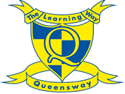
Home learning for Year 4
Week Beginning Monday 4th May 2020

Spelling:
LO: Adding ‘sion’ to words ending in de or d.
Look at the list of words below and discuss what you think each word means. You may like to check using a dictionary. What do you notice about all the words?

divide | collide | explode | corrode
conclude | extend | comprehend | evade
intrude

Did you notice they all end in either de or d and that they are all verbs?
Now you need to change each of the words by adding sion.
What did I have to do to change explode into explosion?
Have a go at changing all the words by adding sion
I have done the first two for you
explode = explosion
extend = extension

divide =
collide =
corrode =
conclude =
comprehend =
evade =
intrude =

Can you think of any other words you could add to the list?
Try and write a spelling rule e.g. When I add sion I have to . . .

Grammar:
Using similes as sentence starters.

Similes are a great way of starting your sentences and can help to make your writing more engaging for the reader. Similes help the reader imagine what you, as the author are describing. They can help the reader create a better image and develop a better understanding of the text. You can make a simile by using the word like or as.
Like a crying baby,… this simile can also be written as Crying like a baby,…

As is used twice when writing a simile. For example: As quiet as a mouse

As still as a statue,…. Think about how you could recreate this simile opener to make it more engaging and different. The idea you are describing here is something being very still – what else could you link with being still or not moving?
Unmoving like a frightened mouse,…
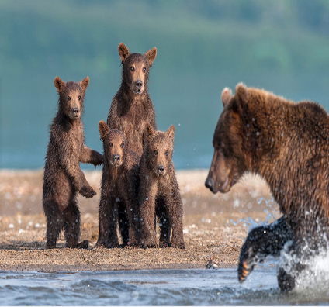
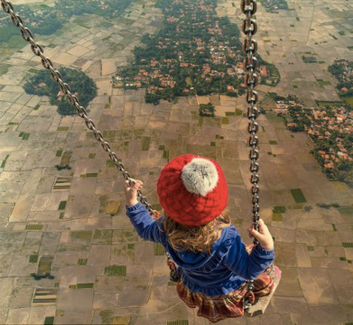

Like the water on a frozen lake,…
Choose an image and come up with four different sentences that each start with a simile. How creative can you be? Make sure that you think about a clear, recognisable comparison.

Reading:
Complete the reading lesson on BBC Bitesize this week on Friday!
You will be looking at the text ‘Dindy and the elephant’ by Elizabeth Laird.
https://www.bbc.co.uk/bitesize/tags/z63tt39/year-4-lessons/1

English:
This week we are going to be describing Egyptian animals. In a story called ‘Pepi and the secret names’ which is set in Ancient Egypt, the author describes different animals. The author of the story uses lots of description to describe the intriguing animals, such as expanded noun phrases and similes.
For example: The hawk dropped like a stone out of the air and landed so close to Pepi that he felt a sweep of air from its wings. Then, wings folded, the great bird stood and stared with anger in his fierce and golden eyes.

This week, we would like you to think about your own creature that could be painted inside a tomb. In the story there is a lion, a hawk, a crocodile and a cobra. What other creatures could you describe? Once you have decided on a creature, write a descriptive paragraph about the animal. Remember, a paragraph is a set of linked sentences. Think carefully about how you are going to describe the animal you have chosen, using interesting similes, adjectives and adverbs. Use your grammar work this week to help you!

We would all love to read and be inspired by your writing, feel free to write it and share it with us as a comment!

Some animal ideas if you are not sure:
In Ancient Egypt, some animals were associated with gods.
- Cat
- Cow
- Falcon or hawk
- Baboon
- Jackal or a fox
- Bull
- Crocodile
- Scarab beetle

http://www.primaryhomeworkhelp.co.uk/egypt/animals.htm

Maths:
Quick recap
Remember, there are 60 seconds in a minute and 60 minutes in an hour.
- How many seconds are there in 6 minutes?
- How many seconds are there in 25 minutes?
- How many seconds are there in 33 minutes?
- How many minutes are there in 4 hours?
- How many minutes are there in 6 hours 15 minutes?
- How many minutes are there in 9 hours 45 minutes?
- How many minutes are equal to 180 seconds?
- How many minutes are equal to 270 seconds?
- How many minutes are equal to 780 seconds?
- How many hours is 420 minutes?
- How many hours is 390 minutes?
- How many hours is 555 minutes?
This week we are going to have a look at reading calendars. Have you got a calendar at home or on your computer? Ask an adult where you can see calendars.
Watch the video below to find out more about calendars
https://www.bbc.co.uk/teach/class-clips-video/maths-ks2-using-a-calendar/zdfgkmn
Use the calendar below to have a go at answering some questions!

Mon | Tue | Wed | Thu | Fri | Sat | Sun
 |  |  |  | 1 | 2 | 3
4 | 5 | 6 | 7 | 8 | 9 | 10
11 | 12 | 13 | 14 | 15 | 16 | 17
18 | 19 | 20 | 21 | 22 | 23 | 24
25 | 26 | 27 | 28 | 29 | 30
November
Phases of the moon: 3: 10: 17: 25:
Holidays and Observances: 5: Guy Fawkes Day, 10: Remembrance Sunday, 30: St Andrew's Day (Scotland)

- What were the dates of all of the Fridays in this month?
- What was the date of the last Sunday in October?
- What was the day 4 days before the 1st November?
- Jim’s birthday is on the 4th of November. He has a party a week later. What is the date of his party?
- Mr Hawman’s birthday was on the 16/11/13. He was 36. In what year was he born?
- Jane’s party was on the 19th of November. She had a party on the Saturday before this date. What date was her party?
- What will be the date on the first Tuesday in December?
- What was the date 4 days before the 7th November?
- November has 30 days. What other months have only 30 days?
- What is the date 10 days after 14.11.11?
- Can you make up some of your own questions to do with this calendar?
PE:
Have a go this week at the ‘sockfest’ challenge! Every few weeks there will be a new challenge added which you can have a go at whilst at home There is a recording sheet on the website if you wish to record your scores.

Have a go at both the physical and cultural challenges this week! https://www.activeoxfordshire.org/school-games/
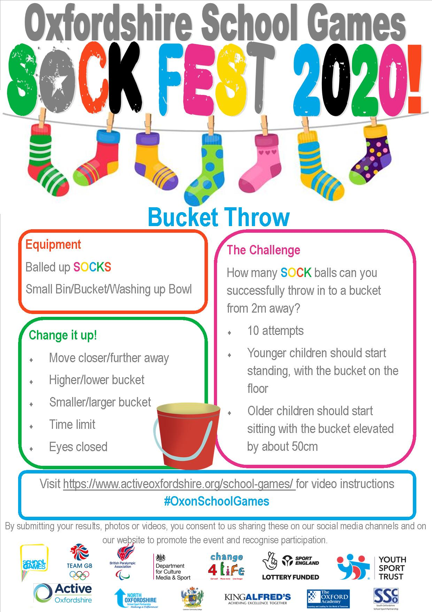

Topic: Science
The digestive system.

This term we are going to be learning all about the digestive system and how it works! To begin our learning, watch Chloe explain all about how the body works https://www.youtube.com/watch?v=VwrsL-lCZYo.

Create a comic strip about the process of digestion. Imagine that you are a piece of food travelling through the body. Print out the comic strip template below or draw your own.

Experiment (optional)
Once you have watched the video above, it is your turn to set up an experiment looking at how the digestive system works, and how food travels through your body. Remember when we looked at the different types of teeth? You are going to think about how each of the types of teeth play a role in the digestive system.
Be prepared to get a little messy!
You will need: Please ensure that you have parental support and supervision during this experiment.
- A sandwich (a banana sandwich works really well for this experiment!)
- Scissors
- A potato masher
- A large bowl
- Water (to act as saliva)
- A zip lock bag
- A spoon
- Vinegar or orange juice (to act as stomach acid)
- A pair of old tights – you will need one leg of the tights for this experiment
- sieve

- Cut the sandwich into smaller pieces using the scissors to represent chewing (the scissors represent the incissors) and then put the smaller pieces into the bowl which represents the mouth.
- Using the potato masher (representing the molars), mash and grind up the sandwich. This can be quite difficult as the food is dry, so add a little water to act as saliva in the mouth.
- Keep mashing until the big lumps have gone.
- Transfer the mixture from the bowl into the zip-lock bag which represents the stomach.
- Add some vinegar or orange juice to the mixture in the bag to act as stomach acid and help break down the food.
- Carefully seal the bag, making sure that all the air has been squeezed out.
- Squeeze the bag, as if acting as the stomach muscles, to churn the mixture up. Keep going until the mixture is thinner in consistency.
- Carefully transfer the mixture from the bag into the tights, making sure that you seal the open end when you have finished.
- Then use your hands to squeeze the mixture from one end to the other, pretending to be the small intestines contracting in the body. As the food passes through the tights (intestines) the moisture will be squeezed out so make sure that you do this over a bowl or kitchen sink. This represents the body absorbing the nutrients from the food you have eaten and it entering the bloodstream.
- The mixture left behind in the tights is mainly indigestible matter and water. The job of the large intestines is to remove the excess water. Now place the sieve over a bowl and cut the end of the tights to allow the mixture to go into the sieve.
- Use the spoon to press the water out of the mixture and into the bowl. Keep pressing until you’re left with a mixture which is firm enough to be moulded. This is the final product of food passing through your body and through the digestive system.

Make sure to take lots of photographs of your experiment to show us! Enjoy

10 top tips for staying safe on the internet
1) Don’t post any personal information online – like your full name, email address, mobile number, etc.
2) Think carefully before posting pictures or videos of yourself. Once you’ve put a picture of yourself online, most people can see it and may be able to download it, it’s not just yours anymore.
3) Keep your privacy settings as high as possible!
4) Never give out your passwords.
5) Don’t befriend people you don’t know.
6) Don’t meet up with people you’ve met online. Speak to your parent or carer about people suggesting you do.
7) Remember that not everyone online is who they say they are.
8) Think carefully about what you say before you post something online.
9) Respect other people’s views, even if you don’t agree with someone else’s views doesn’t mean you need to be rude.
10) If you see something online that makes you feel uncomfortable, unsafe or worried: leave the website, turn off your computer if you want to and tell a trusted adult immediately.



