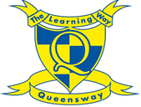
Home learning for Year 4
Week Beginning Monday 11th May 2020

Spelling:
Task one:
Choose some different ways to practice your spellings from the past couple of weeks using the Queensway spelling strategy list - http://www.queensway.oxon.sch.uk/page/?title=Ways+to+support+your+child&pid=122

Task two:
This week we would like you to practice your spelling of those tricky common exception words! Remember to think about which part of the word makes them tricky to spell to help you remember them. You could come up with mnemonics like Big elephants cause an unusual scene everywhere (because) or big elephants live in Europe very eagerly (believe).

accident
accidentally
address
answer
appear
arrive
believe
bicycle
actual
actually

Please focus on the spellings above for this week! Visit the link and click ‘spelling tiles’, then choose one of the games to play. https://spellingframe.co.uk/spelling-rule/26/25-Word-list-years-3-and-4---a-to-bi-

Grammar: subordinating conjunctions
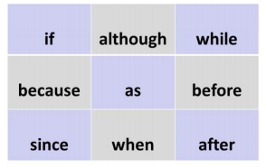
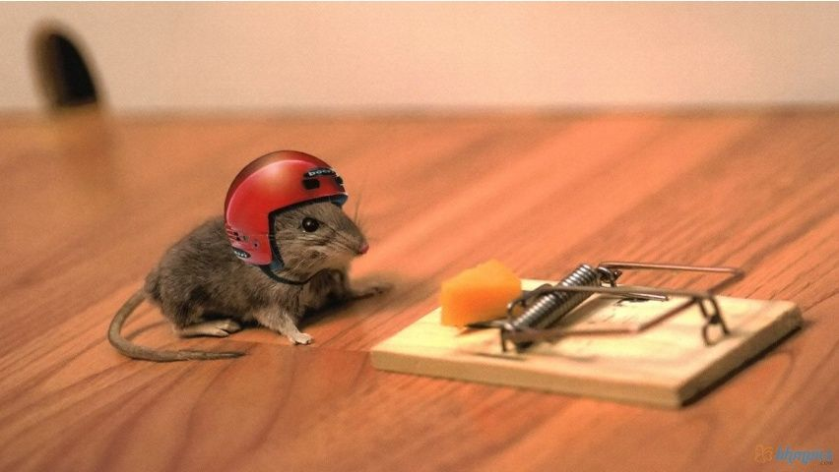

Here is a game for you to play with your parents or siblings. Using the noughts and crosses grid of conjunctions, choose one to create a complex sentence about the picture above. The first person to achieve a diagonal, horizontal or vertical line is the winner, but make sure your sentences are structured correctly. You need to use these words as subordinating conjunctions – be careful because some of them can be used as prepositions depending on the structure of your sentence.
For example: The mouse I had before him would never leave my side, so this one is a far more mischievous. (before acts as a preposition here because it is not joining the clauses – the conjunction so is!)

Watch this learning clip to help you remember their role! https://www.bbc.co.uk/bitesize/topics/zwwp8mn/articles/zqk37p3

Here is a great song too, as I know how much you all love our grammar songs. https://www.youtube.com/watch?v=FK2Gyto5gTQ

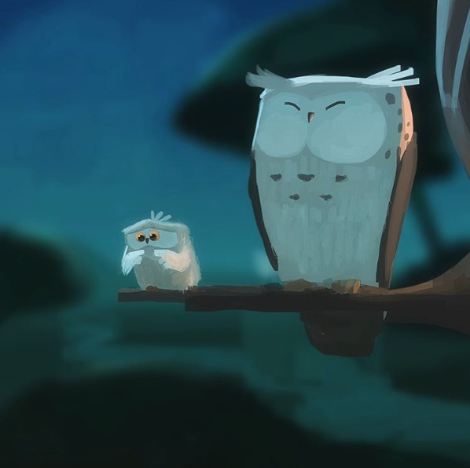
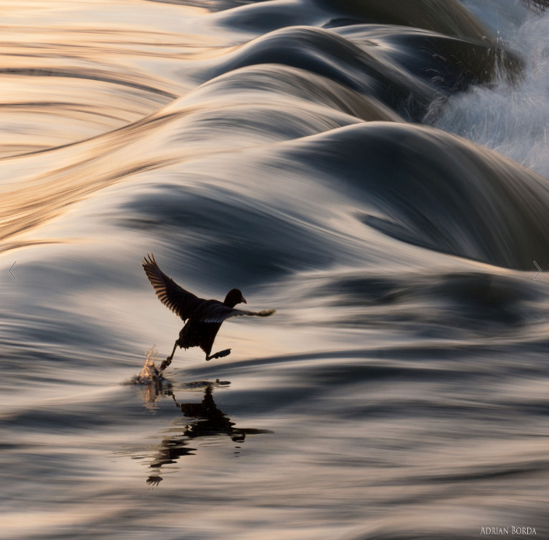
Reading:
- How are the owls related?
- Which owl is taking its first flight? How do you know?
- How does the young owl feel about flying?
- What might it be thinking? Add a thought bubble to the picture.
- Is the older owl worried?
- What advice might the older owl give to the younger one?
- If trying new things is scary, does that mean you should never try them?
- Compare the two images – what is similar? What is different?

Task two:
Remember to keep reading for 15 minutes a day! Complete a book review of the last chapter or book you have read.
Think about these areas to help you:
- characters – describe their personalities
- the plot of the story - is it an enjoyable read?
- your opinion – do you like the book? What was your favourite part and why? Was there any funny or scary bits? Did you learn anything?
- Recommendation – would you recommend this to a friend? Why or why not?
Be careful not to give away too much detail though.
If you would like to, you could share these on the blog so that we are all recommending great stories we have enjoyed reading!

English:
Task one:
This week we would like you to focus on developing your editing skills, thinking carefully about the audience and purpose of your writing. Before you begin, remember why we edit!
Who is the intended audience of your piece of writing?
What is the purpose of the writing? You are aiming to engage the reader, and create an exciting image in their minds eye of your Egyptian animal.

Watch these videos to help you think about the purpose and audience of your writing.
https://www.bbc.co.uk/bitesize/topics/zpccwmn/articles/zsp8srd
https://www.bbc.co.uk/bitesize/topics/zpccwmn/articles/ztph97h

Now watch this video, which will help you with task two. This will help you think about why we edit and check that your writing matches the intended purpose. Complete the tasks at the bottom of this page too before you begin task two.
https://www.bbc.co.uk/bitesize/topics/zpccwmn/articles/zpyhtyc

Task two:
You are not just checking for spellings, this is your chance to improve your writing.
Using your paragraph from last week, work through the editing checklist.

- Read it backwards to check for spellings. Use a dictionary and your known spelling rules to help you!
- Read your work from the beginning to check that it makes sense. Have you missed any words out? Is it written in the right tense?
- Read through your work again, this time checking for punctuation.
- Read through your work one last time – is there anything you would like to add or improve? Could you use a thesaurus here to develop your vocabulary?

https://www.thesaurus.com/ (use the online thesaurus if you don’t have one at home).

Use the BBC teach Writing lesson on Thursday to help you focus on your editing skills.

https://www.bbc.co.uk/bitesize/tags/z63tt39/year-4-and-p5-lessons/1

Maths:
This week we are going to do some work on measures. This will be going over work we have previously done in class. In the video he does talk about the previous lessons he did on area and perimeter but as we have done these already in school you should be fine to answer the questions.
Task 1:
LO: To choose appropriate measures
There is a quick quiz to complete before you move on to the task. You can do this before each task this week.
In this lesson, you will learn about different units of measure for weight, length and capacity. You will also be comparing different units of measure.
You will need:
- Pencil
- Paper

https://www.thenational.academy/year-4/maths/measures-choosing-appropriate-measures-year-4-wk3-1
Task 2:
LO: To convert between millimetres (mm) and centimetres (cm)
In this lesson you will be developing strategies to convert from one measurement to the other and back again.

You will need:
- Paper
- Pencil
https://www.thenational.academy/year-4/maths/measures-converting-between-mm-and-cm-year-4-wk3-2

Task 3:
LO: To convert between centimetres (cm) and metres (m)
The same as last lesson you will be developing strategies to convert from one measurement to the other and back again. We will also consider different ways of representing the same measurements.
You will need:
- Paper
- Pencil
https://www.thenational.academy/year-4/maths/measures-converting-between-cm-and-m-year-4-wk3-3

There are two further lessons in the sequence. It would be great if you have time to do these as well.

Task 4:

LO: To choose and use appropriate units of measure for capacity length and mass
LO: To convert between measures and use previous knowledge of multiplying and dividing by 10, 100 and 1000.

https://www.thenational.academy/year-4/maths/measures-capacity-and-mass-year-4-wk3-4

Task 5:

LO: To solve measure problems

https://www.thenational.academy/year-4/maths/measures-solving-measures-problems-year-4-wk3-5

The National Academy will be adding further lessons on measures. I will add these when they become available.

PE/Active lesson
Task 1:
It would be great to try some more cosmic kids yoga. This should be great for keeping everyone fit, flexible and calm.

- https://www.youtube.com/user/CosmicKidsYoga - Yoga

Task 2:
Follow the link to the supermovers KS2 website where you can choose a video to help you learn and be active at the same time!

https://www.bbc.co.uk/teach/supermovers/ks2-collection/zr4ky9q

Don’t forget to Keep your activity levels up with Joe Wicks’ live PE lessons

https://www.youtube.com/user/thebodycoach1/videos?safe=true Joe Wick’s Live PE sessions

Topic: History – The Discovery of Tutankhamun

Task one:
As we are learning about the Ancient Egyptians, we thought you might like to have a virtual tour of the Tutankhamun exhibition which is in London. Watch the video and read about some of the amazing artefacts included. https://tutankhamun-london.com/see-do/.
Create a small mind map about some of your favourite artefacts that were discovered in the tomb – choose 2 or 3! This will help you with task two.

Task two:
Once you have watched the video and read about some of the artefacts that Howard Carter discovered in 1922, write a letter pretending to be one of the Historians carrying out the archaeological dig. Write a letter to Lord Carnarvon who funded the excavation of the tomb, explaining your findings. Think carefully about why you are writing the letter:
For example:
Dear Lord Carnarvon,
I am writing to inform you about the recent discoveries made here at the tomb of Tutankhamun.
Yesterday, my team and I discovered………
(Explain and describe what you found. Think about your senses! How did it make you feel? Are you happy to have finally found something? Are you excited that his tomb was so well preserved?)
Over the coming days, we hope to find out more.
Yours ____________________________
Howard Carter/your name

Don’t forget to add in lots of detail about the artefacts you have found – think about how you can make the reader picture them in their mind as they won’t have seen them yet. Use your grammar work to extend and develop your ideas.

Task three:
Have a go at drawing your own version of Tutankahmun by following these instructions - https://artprojectsforkids.org/how-to-draw-king-tut/
You will need:
Paper
Colouring pencils or crayons or paint (feel free to explore different mediums).
Black felt tip or sharpie to make the lines clearer at the end.
(Here is Miss Ross’ drawing!)
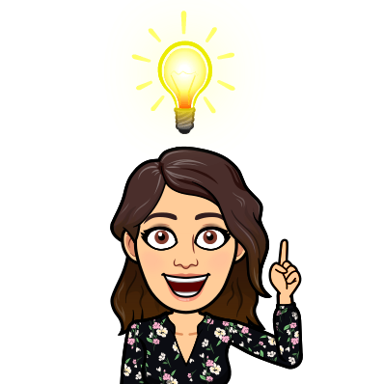
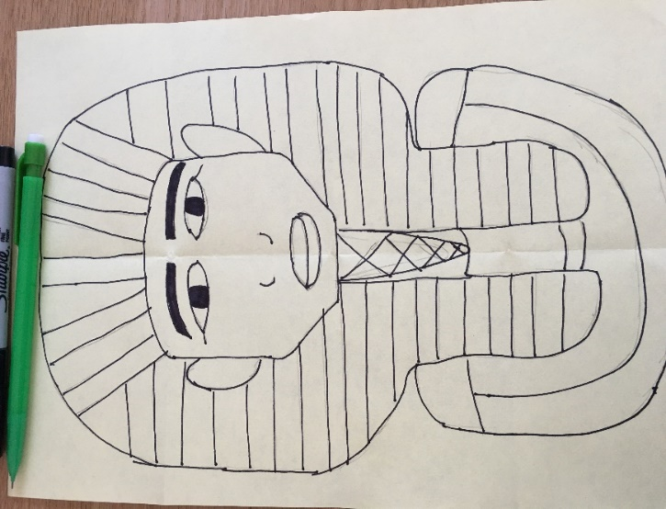
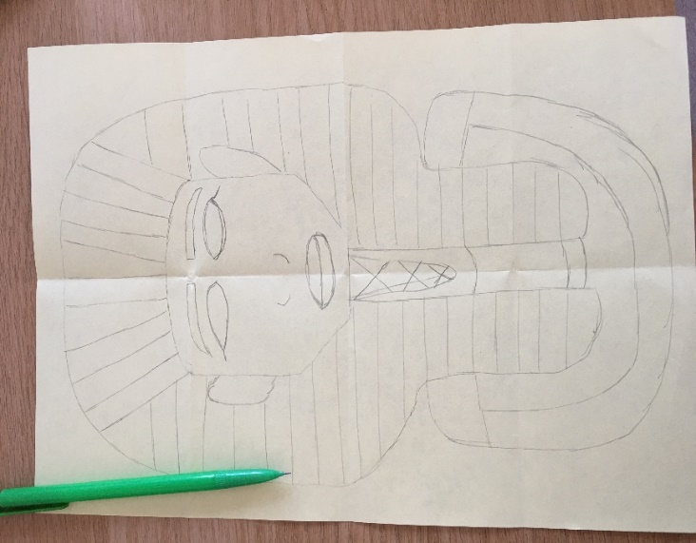
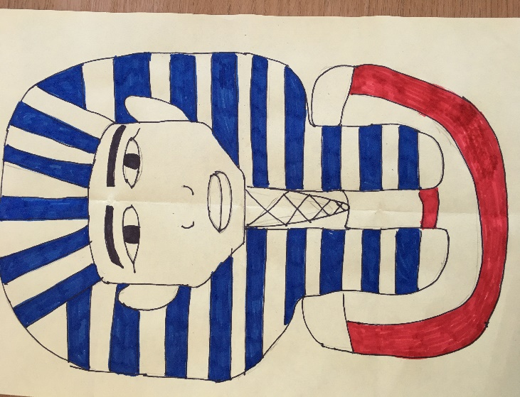
Top tip: Fold the piece of paper into 8 squares to use as your grid lines. It really helps!

10 top tips for staying safe on the internet
1) Don’t post any personal information online – like your full name, email address, mobile number, etc.
2) Think carefully before posting pictures or videos of yourself. Once you’ve put a picture of yourself online, most people can see it and may be able to download it, it’s not just yours anymore.
3) Keep your privacy settings as high as possible!
4) Never give out your passwords.
5) Don’t befriend people you don’t know.
6) Don’t meet up with people you’ve met online. Speak to your parent or carer about people suggesting you do.
7) Remember that not everyone online is who they say they are.
8) Think carefully about what you say before you post something online.
9) Respect other people’s views, even if you don’t agree with someone else’s views doesn’t mean you need to be rude.
10) If you see something online that makes you feel uncomfortable, unsafe or worried: leave the website, turn off your computer if you want to and tell a trusted adult immediately.

