Can you find the winner of the Quidditch cup?
Add each team’s score together to work out their total.
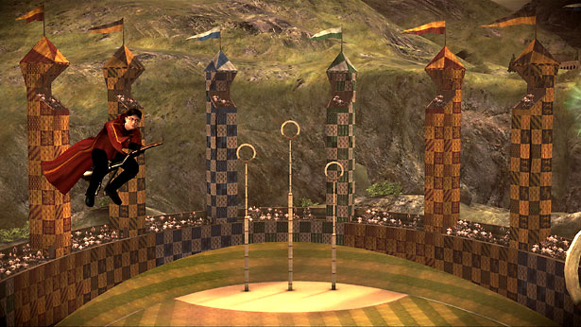

 | Gryffindor   | Slytherin   | Ravenclaw | Hufflepuff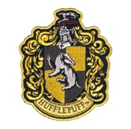
Match 1 | 1065 | 5400 | 2100 | 2133
Match 2 | 233 | 1030 | 6031 | 1304
Match 3 | 4986 | 1215 | 1426 | 4066
Match 4 | 3104 | 2326 | 1250 | 1255

Gryffindor

Slytherin

Ravenclaw

Hufflepuff

Oh no! Each team lost some points for an illegal flying move.

Gryffindor lost 2270
Slytherin lost 1557
Ravenclaw lost 1083
Hufflepuff lost 605

Which team is the winner of the Quidditch cup?

