Rhyming Tree
Write your root word at the bottom of the tree trunk.
How many rhyming words can you add to the branches?
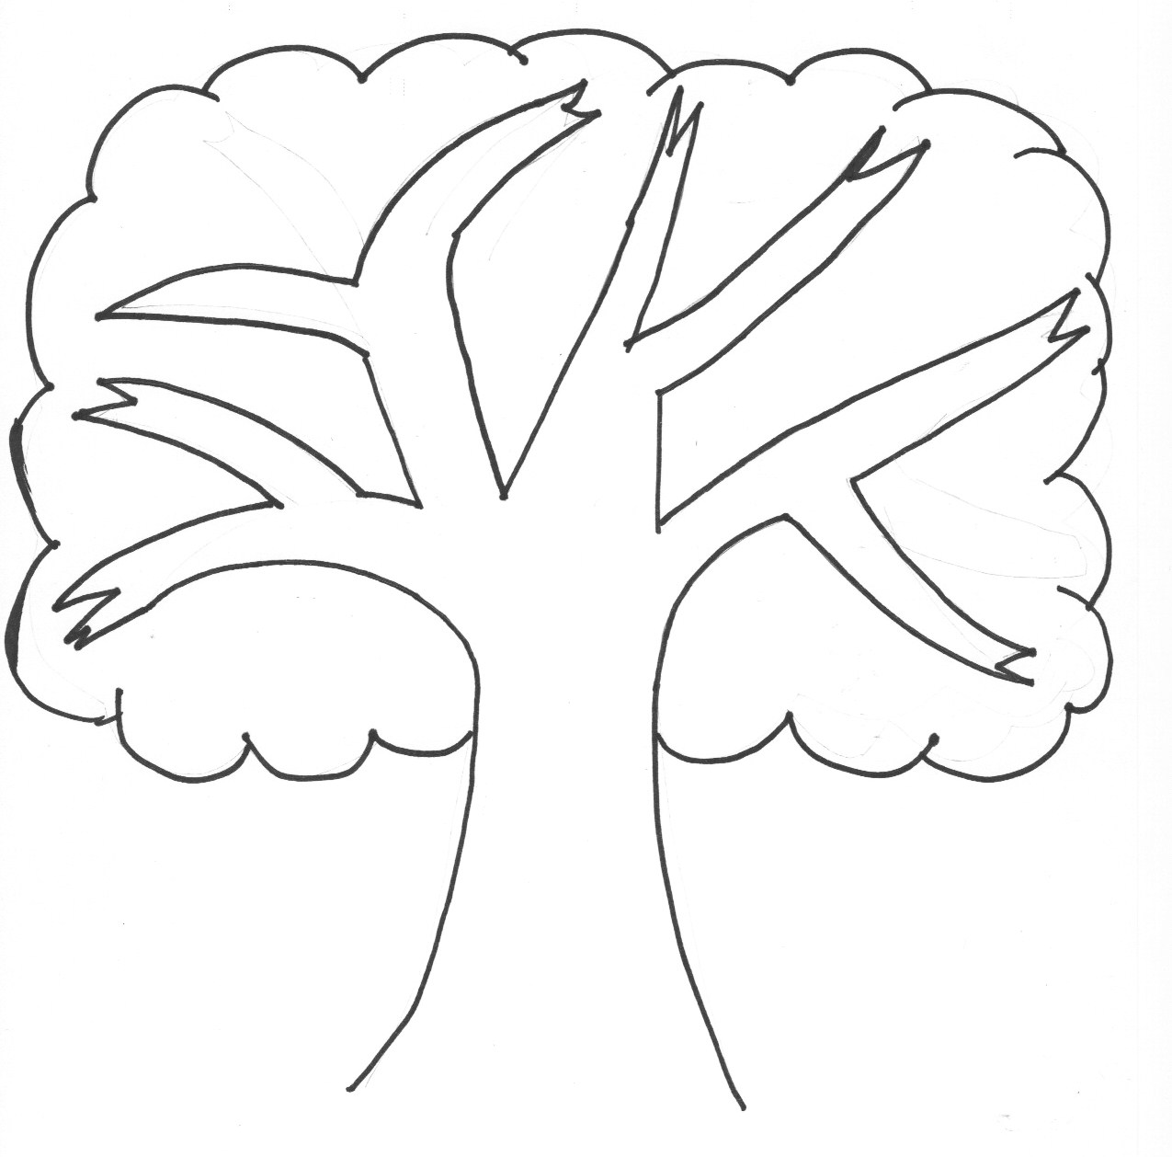
If you need more branches, add them!
If you get stuck, ask the person next to you for their ideas.

